Lab Manual – Display Memory
Important Instructions:
- Make proper subroutines
- Use Delay Function, that we did in class (if required)
Activity 1 [Moving Star]: Write a function MovingStar that shows an asterisk ‘*’ moving from Top-Left to Top-Right to Bottom-Right to Bottom-Left back to Top-Left. Your program should terminate after one round.
Activity 2: Update code written in activity 1 such that the star travels the screen in an infinite loop.
Activity 3: Code to clear screen is given in example 7.1. Your task is to modify this code and print ‘_’ (underscore) on first 13 rows of screen and ‘.’ In rest of the rows. Required output is given below. Properly calculate the cells required with each character.
Required Output:
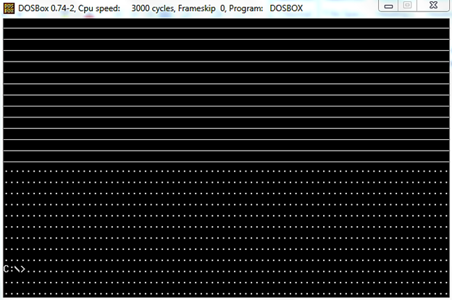

We did following code in class:
; clear the screen
[org 0x0100]

mov ax, 0xb800 ; load video base in ax
mov es, ax ; point es to video base
mov di, 0 ; point di to top left column
; es:di pointint to --> 0xB800:0000 (B8000)

nextchar: mov word [es:di], 0x0720 ; clear next char on screen
add di, 2 ; move to next screen location
cmp di, 4000 ; has the whole screen cleared
jne nextchar ; if no clear next position

mov ax, 0x4c00 ; terminate program
int 0x21

Activity 4: Update above code such that it prints all characters (ASCII 0 to 255) on screen starting from location zero onwards and fills all the screen as shown in the figure below:
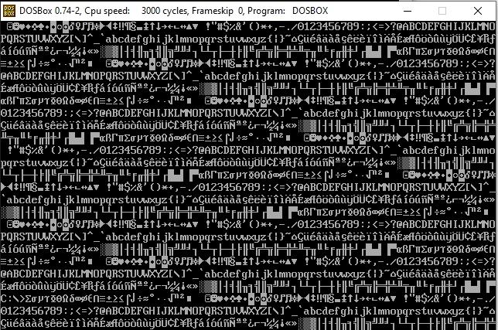
Activity 5: Update the code written in Question 1 to print blinking characters with high intensity as shown in the figure below:
